How to Request Email (and other) Records from Calvert County Public Schools

Requesting email and other records can provide valuable insights into circumstances and conditions surrounding CCPS students, teachers, administrators and staff. For emails, it is important to be aware of the CCPS email and archive systems, so you can properly structure your request and ensure CCPS responds to it completely and accurately. When we performed our PIA request for email communications it took an excessive amount of time, almost 3 months, to receive our records and when we did receive them we were overcharged thousands of dollars and found many emails had been removed. We are providing information we learned to help others who may wish to make similar requests. Just pick out the parts that apply to your request.

CCPS has utilized Microsoft Office 365 (O365) since 2015 to provide email communication services for administrators, faculty, staff and students. All full-time CCPS employees, staff and students receive an O365 mailbox and an email address ending in @calvertnet.k12.md.us. Some part-time employees receive these as well, although it seems to depend on the length of employment, for example, in our experience, two short term substitutes who were each there for several months received mailboxes while another short-term substitute who was only there for around a week supposedly did not.

CCPS archives electronic copies of all email communications sent or received by CCPS users regardless of whether messages are deleted or moved. There are two systems currently in place to archive mail, Office 365, which has built-in archiving and litigation hold features, and Gaggle, which is a 3rd party email archive utility capable of archiving messages from multiple email platforms including O365. The archive capability built-in to O365 was available in 2015 but according to John McClellan, former IT director for CCPS, it was not “turned on” until 3/7/17. Gaggle has been used by CCPS for some time including well before O365 was deployed in 2015. Mr. McClelland claimed messages received before 3/7/17 are archived only in Gaggle while messages received on or after this date are archived in both O365 and Gaggle. We do not know whether CCPS will continue to utilize Gaggle going forward for new email items; however, CCPS says they must continue to maintain it to have access to older email items. When conducting your PIA email request inquire with the CCPS Records Custodian about which archive platform will be used to perform the search as this will be important when further scoping your request and they can either provide the answer or refer you to someone in CCPS who can.

Both O365 and Gaggle provide robust search query capabilities to allow administrators to easily scope searches to specific criteria. This includes the ability to specify multiple criteria in a single search to eliminate the need to do multiple searches. In request we asked for the request to be scoped to messages sent to and from 29 specific users. When doing the search, the IT director instead chose to run a total of 58 searches, including one to and one from each person, for each of the 29 users. This resulted in costs which were 58 times what they should have been had the IT director used the available search tools. It isn’t just the search time that adds up when done in this fashion, the cost of exporting and saving the results to disk also adds up and compounds the overall time. Understand that the if the IT director is doing the searches, as he did ours, they will charge you $80/hour for performing this work. When a single search is done there is only one set of results which must be exported and saved to disk. When filing your request insist that CCPS utilize the available search criteria and don’t accept more than an hour of search time for every 5,000 email items. We had approximately 7,000 email items returned in the searches but were billed for 19.33 hours for a total charge of $1546.40. The actual charge should have been between closer to $100 total.

O365 and Gaggle have similar search criteria, but they are slightly different in how user mailboxes are filtered. The important fields in an O365 search are **Keywords**, **Recipients**, **Senders** and **Date** as shown in the graphic below.

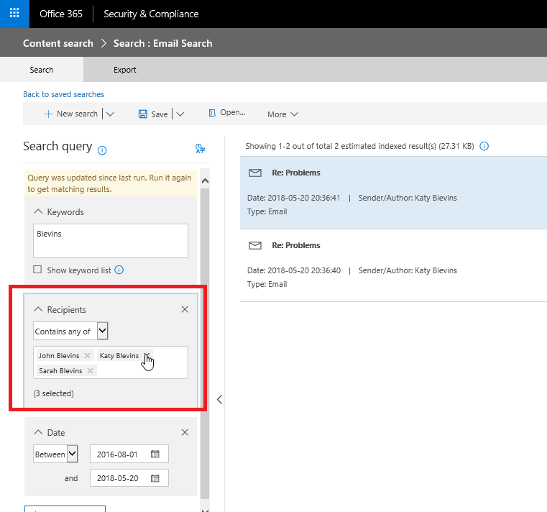

The **Keywords** field should be populated with word(s) to search for in the email subject and body. The student’s last name is a good search term to use. We included our last name, Blevins, which is not a common last name in the school district and were able to reduce the return results to just our children. If your last name is more common within the school system, and more records are returned you may want to consider using additional keywords to narrow the scope further. For the **Recipients** and **Senders** fields the “contains any of” operator can be specified to include multiple senders and recipients in a single query. The **Date** field helps to narrow the return results by looking for mail items sent or received within the specified time window. **UPDATE In CCPS it is common practice to refer to students and staff with abbreviations. Ex., Jane Doe could be JaDo, Ja Do, JanDoe, Jan Doe or Ja. Do, etc... (capitalization unimportant) This tactic is to avoid creating searchable records with full names. Including these forms of abbreviations could be helpful criteria to add to your search as well.**

The important fields in a Gaggle search are **Has the Words**, **Users**, and **From**/**To** **Dates** as shown in the graphic below.

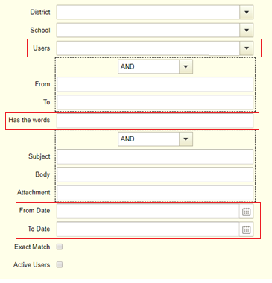

The **Has the words** field, similarly to the O365 Keywords field, should be populated with word(s) to search for in the email subject and body. The **Users** field limits the search to mailboxes for certain specified users. When using this filter, you don’t need to specify values in the From and To fields because the search will be limited to the specified mailboxes with no further recipient/sender scoping needed. When we did our PIA request CCPS refused to use this field to limit the scope of the search and it ended up returning thousands of duplicate messages from users’ mailboxes we didn’t care about. The **From Date** and **To Date** fields helps to narrow the return results by looking for mail items sent or received within the specified time window. Timebox your request to include a beginning and end date, so there are no searches performed over different spans of time, which makes it harder to analyze the email results. Ex., instead of “01/01/01 until the present,” say “01/01/01 until 02/02/02.”

Once you feel good about the search criteria ask CCPS for a “count sheet” that shows the search results. This is an important item to obtain because it is used to later validate the number of emails produced when you pick up the records. The count sheet can be produced from the Gaggle or O365 service and shows important metadata about the search query including the search query syntax used, the search date and time, the number of records produced, the search time and the user who initiated the search. Here is an example of what you should receive:

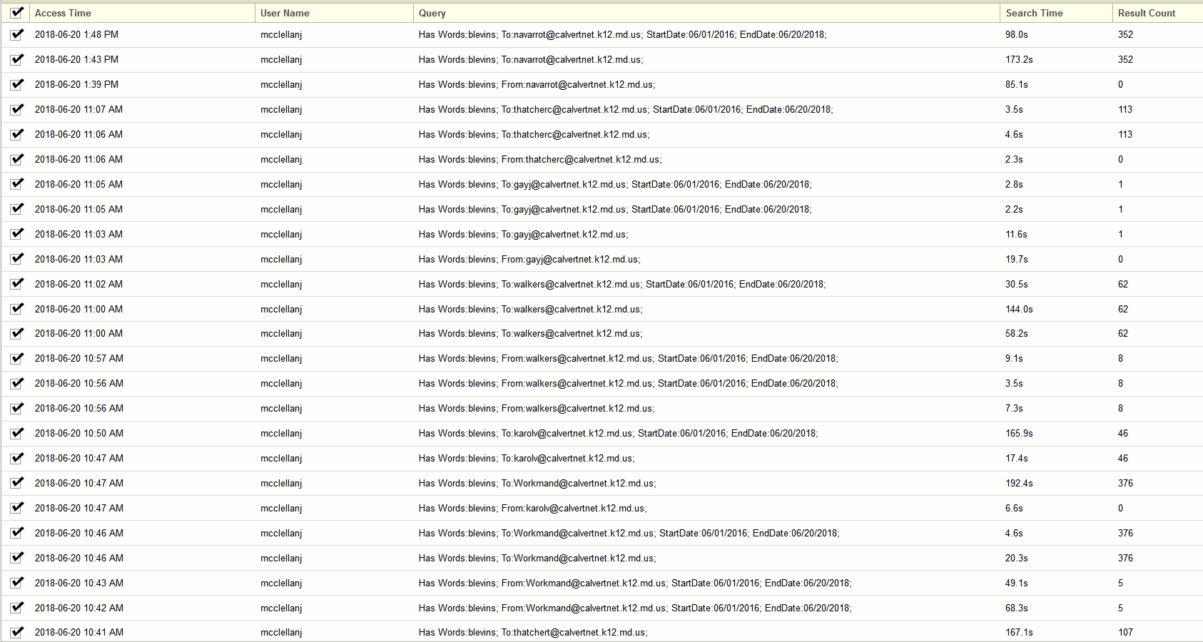

The count sheet should be a print out or export from the Gaggle or O365 system. The count(s) should match the number of records you receive during record pickup. This ensures no records were removed from the results. So, check your count sheet for any lines missing (Gaggle has 25 lines per page) and anything that looks like it could have been cut and pasted, as happened with ours. With the Microsoft Platform it may be harder to determine if lines have been removed, so if you can, insist Gaggle be the search platform used. Also, as the former IT Director claimed that Microsoft o365 was used for retention only from March 7, 2017 forward, time frame could be a factor.